|  |  |  |  |  |
| --- | --- | --- | --- | --- |
| a | b | c | d | f |
| 0 | 1 | 1 | 0 | 1 |
| 1 | 0 | 0 | 1 | 1 |
| 1 | 1 | 0 | 0 | 1 |
| 1 | 1 | 0 | 1 | 1 |

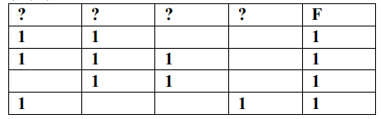

|  |  |  |  |  |
| --- | --- | --- | --- | --- |
| b | a | d | c | f |
| 1 | 0 | 0 | 1 | 1 |
| 0 | 1 | 1 | 0 | 1 |
| 1 | 1 | 0 | 0 | 1 |
| 1 | 1 | 1 | 0 | 1 |